**University of Engineering and Management, Kolkata**

**NEWTOWN, RAJARHAT**



**Database Management System LABORATORY**

**NAME : Shubham Dutta**

**CLASS : CS-2B**

**YEAR : 2ND YEAR**

**SEMESTER : 4th SEMESTER**

**SECTION : 2B**

**ROLL NO. : 58**

**ENROLLMENT : 12019009022112**

**ASSIGNMENT 5**

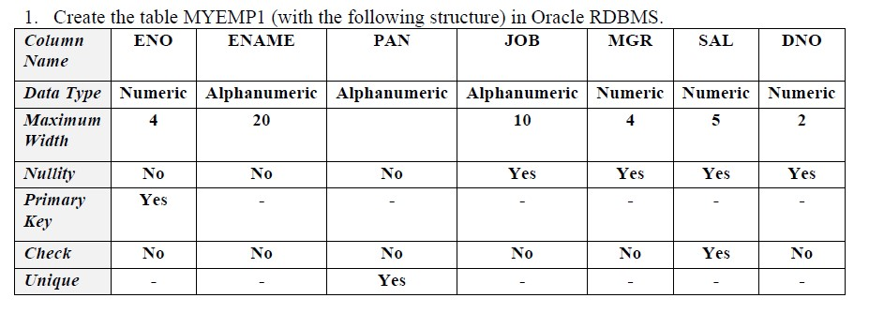

a) Add bonus Column to myemp1 table. Take bonus as of type number with size 10.

b) Alter table to add check constraint. Example: Add check constraint with name

bonus_ck to check bonus given to every employee should not exceed salary.



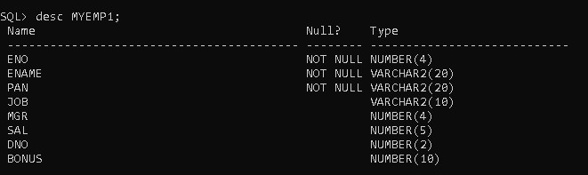

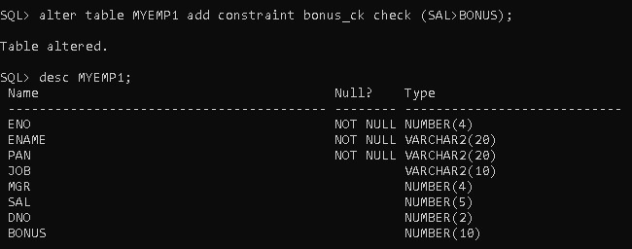

2. a) Create a table Depart with the columns dept_id, dept_name, location_name where

dept_id is primary key.

b) Create another table Employ with the columns empid, name, salary, address,

hire_date, department_no where empid is primary key.

* Make a referential integrity between department_no and dept_id. Also make sure that

salary must contain some values in all rows and each department’s name is different.

* Give appropriate names to all the constraints being imposed on both the tables. Insert at least 3 rows in departments table. Insert at least 5 rows in the employees table with

different department names.

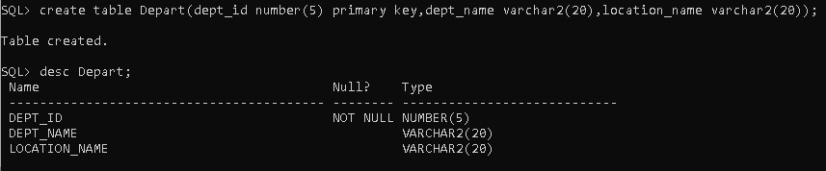

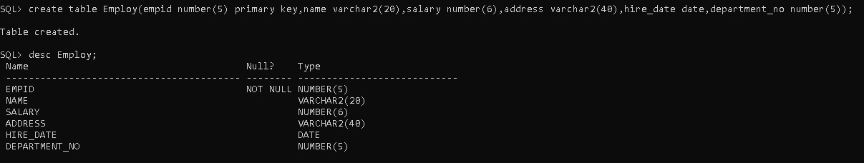

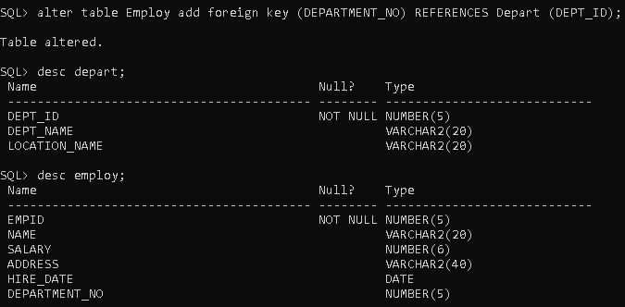

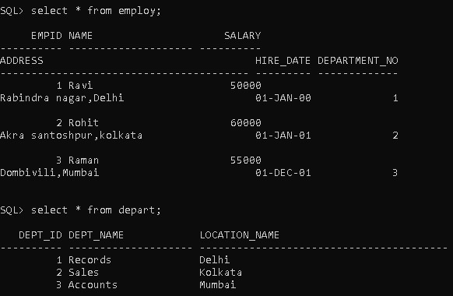

3. a) Create a table Departments with the columns dept_id, dept_name, loc_name where

dept_id is primary key.

b) Create other table locations with the columns location_id, location_name, area where

location_id is primary key.

* Ensure that location_name acts as another candidate key of the locations table. Make

a referential integrity between loc_name of departments table and location_name of

locations table.

* Ensure that dept_name should starts with ‘C’

* Give appropriate names to all the constraints being imposed on the tables. Insert at

least three rows in both the tables.

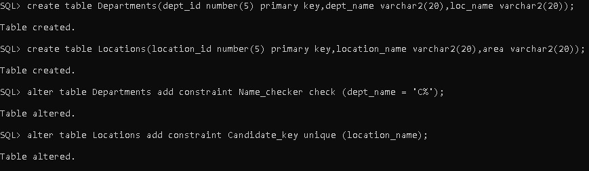

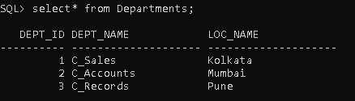

4. a) Create a table Employees with the columns empid, name, salary, address, hire_date,

mgr_no,dept_name where empid is primary key.

* Make a referential integrity between emp_id and mgr_no.

* Give appropriate names to all the constraints being imposed on the tables. Insert at least 10 rows in the employees table with different department names (Make one department name BCA).

